NKU-Collaboration

What we did：

Helping NKU-iGEM construct their plasmid

The cleavage sites XbaI and SacI were added by PCR before and after lysase (lys)

Upper Primer：gcTCTAGAATGAAATACCTGCTGCCGAC

Lower Primer：cGAGCTCtcaatgcgtttccataatagcagc

After the PCR product was harvested then cleavage：

Cutsmart® buffer 5μl

XbaI 1μl

SacI 1μl

PCR product 43μl

After overnight digestion with the linearized plasmid pEX18 for 1 hr

Transformation of the large intestine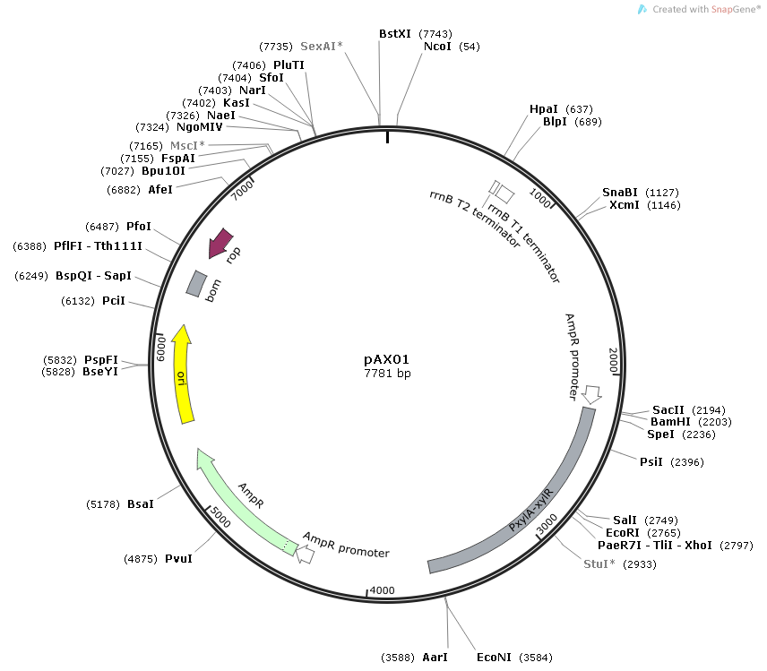

PxylA-xylR was cleaved by SacI on plasmid pAX01

The pEX18-lys, which has been added with lys, was linearized by SacI single digestion

The two are connected after 1hr

Transform into E.coli

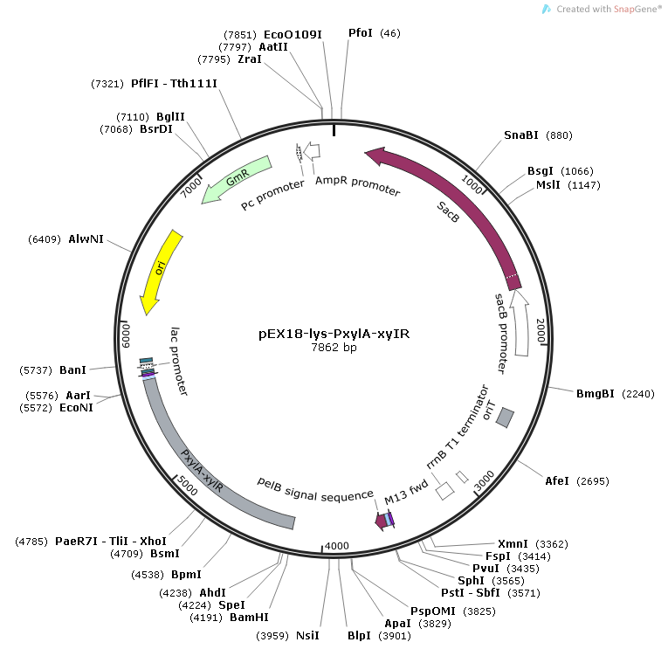

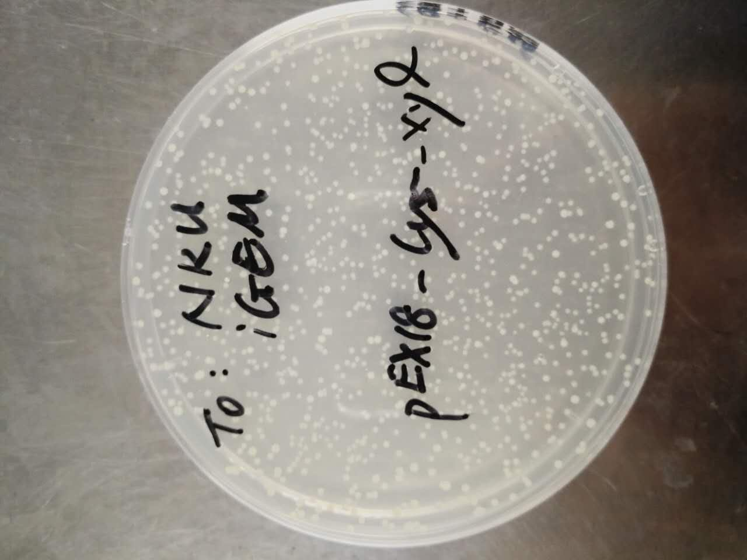

E.coli after transformation

：

Helped us to determine the fluorescence intensity of pRS416-CUP1p-RFP without copper induction in Saccharomyces cerevisiae BY4742 and BY4741.

Cultures were incubated overnight in SC-URA medium

Take the bacteria to the new SC-URA to adjust the OD600 value to 0.1 for 24 hours

Fluorescence was measured

Excitation 472nm

Radiation 532nm

In the case of

the data provided to iGEM-Tianjin for reference